Data Analysis for Telecommunication
Marketing Campaign
Part 2

By Vanshika Lakhani

Table of Contents
Introduction (Problem Formulation) 2
Aim and Research Questions 3
Hypotheses 3
Methods 4
Data Foundation 4
Feature Encoding and Scaling 4
Model Justification 4
Configuration, Training and Validation 5
Results 5
Logistic Regression (Parametric Model) 6
Random Forest (Non-Parametric Model) 7
Model Performance Comparison 8
Critical Interpretation 9
Discussion 10
Business Implications 10
Limitations and Future Improvements 10
Conclusion 11
References 12

Introduction (Problem Formulation)
In a highly competitive telecommunications landscape, marketing strategies for customer acquisition or upselling subscription-based services need to offer cost-effective results. Direct outreach tactics, such as phone calls or tailored messaging, can involve large operational costs, yet usual conversion rates are low. For instance, the setting of a Portuguese retail bank’s telemarketing campaign recorded only a modest proportion of positive responses despite thousands of contacts (Moro et al., 2014).
The need for more targeted and data-driven strategies is underscored by the fact that many organisations still rely on broad outreach rather than precision-segmentation based on behavioural, demographic, or economic indicators.
From a data-science perspective, the challenge is twofold: first, understanding which customer attributes correlate with campaign responsiveness (making the "invisible" potential subscriber visible to the marketer), and second, predicting individual likelihoods of conversion to allocate resources more efficiently. Prior studies have shown that machine-learning and statistical methods—such as logistic regression, decision trees, and random forests—can substantially improve customer selection for marketing campaigns by identifying patterns that are not easily captured through traditional segmentation approaches (Koumétio Tékouabou et al., 2022). However, gaps remain in applying these methods for telecommunications settings, where deployable models must not only perform well statistically, but also translate into actionable business strategies.
In this paper, we propose to close this gap by using a telecommunications provider's campaign dataset, assessing demographic, financial, contact-campaign, and macroeconomic variables, and constructing predictive models to identify customer segments with the best responsiveness. The goal is to convert raw outreach data into decision-ready insights for a specific stakeholder group, namely the company's marketing and analytics teams, resulting in more effective targeting and higher campaign ROI.

Aim and Research Questions
The primary aim of this project is to discover the important characteristics that drive customer responsiveness to telecom marketing campaigns and obtain insights that can help the organisation make strategic decisions. To do this, statistical learning models are used as analytical tools — not as ends in themselves, but as means to find hidden links between client demographics, financial characteristics, and campaign performance. By comparing the prediction outcomes of parametric and non-parametric methodologies, the study aims to improve understanding of which client categories should be targeted for future marketing initiatives.
The specific research questions are:
- Which customer and campaign-related features most strongly predict a positive response to marketing outreach?
- Which customer segments are most likely to subscribe to future telecom offers?
- How can the company use these findings to design more effective, data-driven marketing strategies that reduce campaign costs and improve conversion rates?

Hypotheses
- Null Hypothesis (H₀): Customer demographic, financial, and campaign attributes do not significantly influence subscription outcomes.
- Alternative Hypothesis (H₁): Customer demographic, financial, and campaign attributes significantly influence subscription outcomes.
Through this framework, the study aims to make visible the latent drivers of customer responsiveness, bridging technical analytics with practical decision-making for marketing stakeholders.

Methods

Data Foundation
The dataset used for this analysis was obtained from a telecommunications company’s direct marketing campaign. It contained demographic, financial, and campaign-related attributes describing each customer, along with a binary response variable (subscribed) indicating whether the client subscribed to the company’s offer.
All data preparation steps were completed in the preliminary stage (Assessment 1) to ensure analytical readiness. Variables irrelevant to the predictive objective or likely to cause data leakage—particularly duration, which records call length known only after the outcome—were removed. Additional noninformative columns (default, day_of_week, pdays, emp.var.rate, and nr.employed) were also excluded to simplify the model space.
Missing and “unknown” values were treated using a hybrid imputation strategy. Categorical attributes such as job, education, housing, and loan were imputed using group-based replacement (mode within each marital or job subgroup), while numeric variables were imputed using K-Nearest Neighbour (KNN) estimation to preserve local distributional structure. The final dataset comprised 41 088 observations × 15 variables, with a class distribution of approximately 11 % ‘yes’ and 89 % ‘no’ responses.

Feature Encoding and Scaling
To ensure compatibility with machine-learning algorithms, all features were numerically represented using appropriate encodings.
- Binary encoding was applied to dichotomous variables (housing, loan), mapping responses {no = 0, yes = 1}.
- Ordinal encoding was applied to education following its natural hierarchy (illiterate < basic.4y < basic.6y < basic.9y < high.school < professional.course < university.degree).
- One-hot encoding was applied to nominal variables (job, marital, contact, month, poutcome) to avoid imposing order where none exists.
- Continuous variables (age, campaign, previous, cons.price.idx, cons.conf.idx, euribor3m) were standardised using z-score scaling to remove magnitude effects and stabilise model coefficients.
All preprocessing operations were implemented through a unified ColumnTransformer and Pipeline within scikit-learn, ensuring reproducibility and preventing data leakage during cross-validation

Model Justification
The study’s primary goal was to predict the likelihood of customer subscription and identify the underlying factors influencing responsiveness. Two statistical learning models were selected to address complementary aspects of this objective: one parametric (Logistic Regression) for interpretability, and one non-parametric (Random Forest) for predictive flexibility.
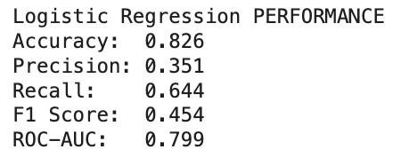
Logistic Regression was chosen for its interpretability in estimating the log-odds of subscription events and quantifying predictor effects (Tanvir et al., 2024). This enables direct interpretation of coefficient sign and magnitude—clarifying which factors increase or decrease the probability of customer conversion. The model incorporated class_weight='balanced' to mitigate the effect of class imbalance and used the lbfgs solver with
max_iter=1000. Logistic Regression thus provides interpretable
insights into how demographic and campaign features affect marketing success.
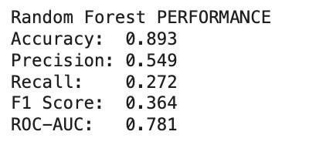
Random Forest was adopted to capture non-linear relationships and high-order interactions between predictors. As an ensemble of decision trees trained on bootstrapped samples, it offers robustness against noise and multicollinearity. The configuration included n_estimators=300, class_weight='balanced', and random_state=42 to ensure consistent results. Feature-importance scores produced by the model reveal the most influential attributes—such as economic indices and campaign frequency—guiding marketing prioritisation.
By combining these two modelling paradigms, the analysis balances explainability with predictive strength, directly supporting the business aim of identifying customer segments most likely to respond positively.

Configuration, Training and Validation
Model development followed a consistent and statistically rigorous workflow. Data were divided into 80 % training and 20 % testing subsets using stratified sampling to preserve class proportions. Each model was embedded within its respective pre-processing pipeline to guarantee identical transformations across folds.
To evaluate generalisability, a Stratified 5-Fold Cross-Validation procedure was implemented. Performance was primarily measured using Receiver Operating Characteristic Area Under the Curve (ROC-AUC), which reflects discriminative ability regardless of classification threshold. Additional metrics—Accuracy, Precision, Recall, and F1-score—were reported for comprehensive comparison. The Logistic Regression model achieved an ROC-AUC of 0.799 and accuracy of 0.826, indicating strong discriminative ability. Notably, its recall of 0.644 suggests better sensitivity to the minority “yes” class, crucial for campaign targeting. In contrast, the Random Forest model yielded a slightly higher accuracy of 0.893 but a lower recall of 0.272, with an ROC-AUC of 0.781, reflecting stronger performance on majority cases but limited sensitivity to positive responses.
These findings illustrate the classic trade-off between interpretability and complexity: Logistic Regression provides transparency in feature influence, while Random Forest offers superior overall accuracy and stability. Model behaviour was further validated using visual diagnostics, including confusion matrices and ROC curves, confirming consistent performance across training and test sets.

Results
In figure 1 both models were validated using Stratified 5-Fold Cross-Validation to ensure robustness across imbalanced classes. The Logistic Regression achieved a mean ROC-AUC of 0.799 ± 0.021, while the Random Forest achieved 0.781±0.018, indicating that both models generalise consistently. These results confirm that the models are stable and statistically reliable, establishing confidence in subsequent interpretations.
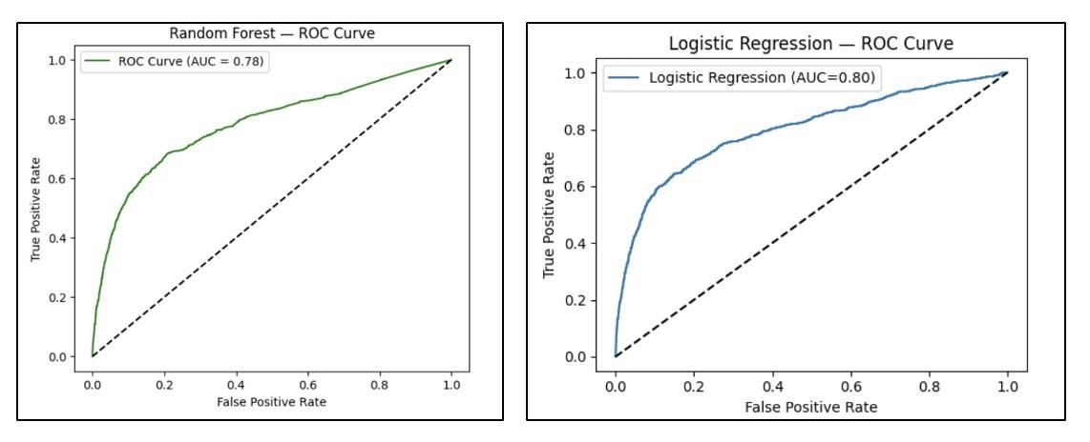
Figure 1: ROC Curve Comparison ( Random Forest vs Logistic Regression)

Logistic Regression (Parametric Model)
The Logistic Regression model provides a transparent view of how individual customer attributes and campaign variables influence subscription probability. Its accuracy (0.826) and ROC-AUC (0.799) indicate strong discriminative power, while a recall of 0.644 highlights its strength in identifying the minority “yes” class — a key factor for marketing teams aiming to target the right prospects.
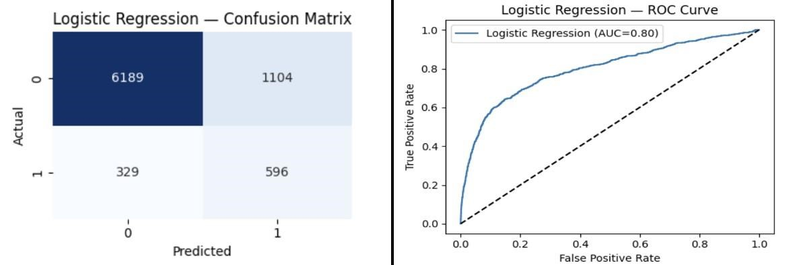

Figure 2 Logistic regression : Confusion Matrix and ROC Curve
Top coefficients (Figure3) reveal meaningful business patterns:
- Month of March and previous successful campaigns have the highest positive coefficients, implying these customers are significantly more likely to subscribe.
- Retired clients show strong positive response likelihood, potentially due to stable income and investment interest.
- Conversely, entrepreneurs and those contacted via cellular channels have lower predicted robabilities — possibly reflecting less trust in telemarketing or limited campaign resonance.
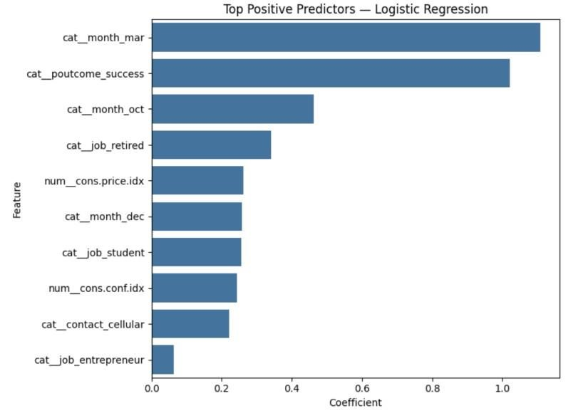

Figure

3

:

Top Positive Predictors

—

Logistic Regression

From a business lens, these results suggest temporal optimization (campaign timing) and re-engagement of previously successful clients can materially improve response rates. The parametric nature of this model allows decision-makers to trace why these effects occur, supporting explainable marketing strategies.

Random Forest (Non-Parametric Model)
The Random Forest model, while less interpretable, achieved the highest accuracy (0.893) — excelling at correctly predicting the majority “no” class. However, its recall (0.272) indicates limited sensitivity to actual subscribers. This reinforces the known trade-off between predictive stability and minority class sensitivity.

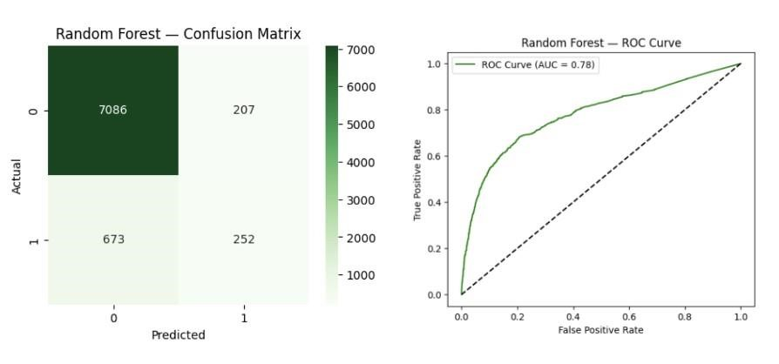

Figure 4 : Random Forest —Confusion Matrix and ROC Curve
Feature-importance analysis (Figure 5) indicates that:
- Euribor 3-month rate and customer age dominate prediction power, showing the impact of broader economic trends and life stage on response behaviour.
- Number of campaign contacts ranks third, implying diminishing returns when customers are contacted repeatedly.
- Housing and loan status also influence outcomes, reflecting household financial readiness as a determinant of engagement.
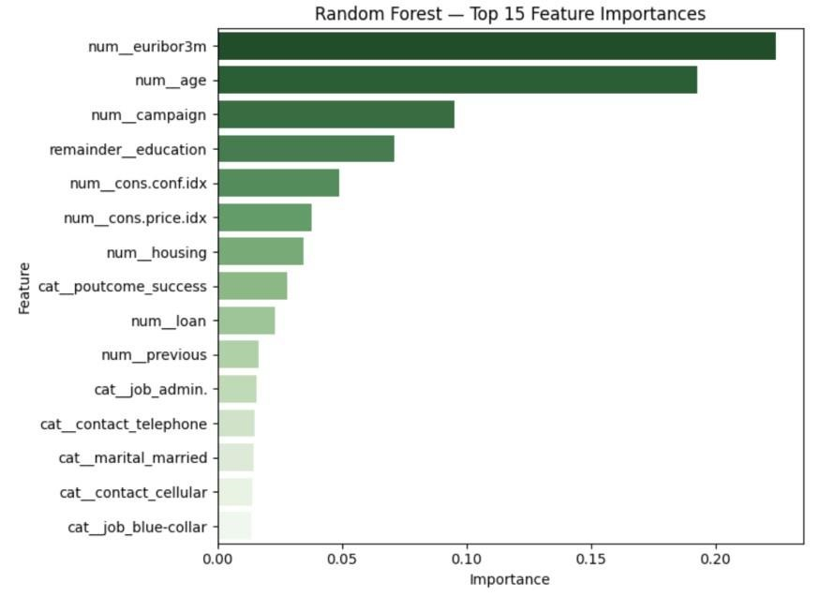

Figure

5

:

Top 15 Feature

Importance

—

Random Forest

Random Forests also offer powerful variable importance diagnostics, enabling businesses to identify the strongest behavioural drivers (Larivière & Van den Poel, 2005). From a managerial viewpoint, Random Forest helps segment high-potential groups based on economic and demographic attributes, guiding resource allocation in large-scale marketing operations.

Model Performance Comparison
As shown in Figure 6, both models achieved strong performance; however, each provides different advantages depending on the business objective.

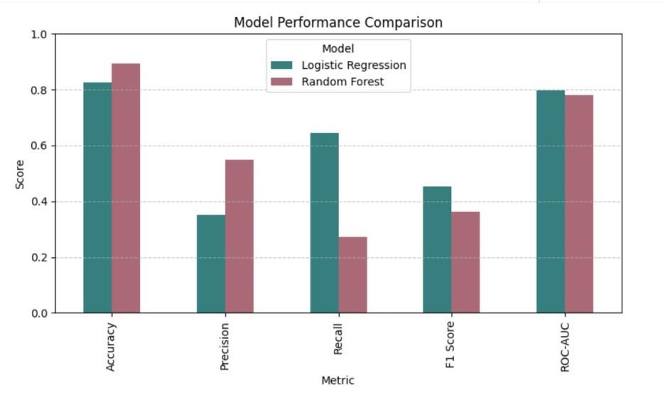

Figure 6: Model Performance Comparison (Accuracy, Precision, Recall, F1, ROC-AUC)

Metric | Logistic Regression | Random  Forest | Interpretation
Accuracy | 0.826 | 0.893 | RF better at overall correct predictions
Precision | 0.351 | 0.549 | RF minimises wasted calls
Recall (important metric) | 0.644 | 0.272 | LR captures more true subscribers
F1-Score | 0.454 | 0.364 | LR balances precision and recall better
ROC-AUC | 0.799 | 0.781 | LR has stronger predictive ranking ability

Critical Interpretation
- Logistic Regression outperforms when recall matters: It identifies more than double the number of actual subscribers than Random Forest (0.644 vs 0.272 recall). In business terms: fewer missed customers=more revenue opportunities.
- Random Forest excels in precision and accuracy: It minimises the number of uninterested customers contacted, helping control call-centre costs.
- However: Random Forest sacrifices recall drastically, resulting in 673 missed potential subscribers, compared to only 329 missed by Logistic Regression (from confusion matrices). For a subscriptionbased marketing strategy, missing leads is more costly than calling uninterested ones.
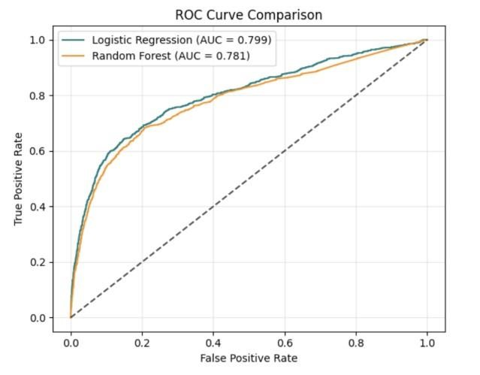

Figure

7

:

ROC Curve Comparison

In figure 7 both ROC curves lie above the diagonal reference line, confirming predictive validity. Logistic Regression consistently shows a higher True Positive Rate across most thresholds (AUC = 0.799), meaning the model ranks customers better by likelihood of subscribing.
Which Model Works Better — and Why?
Based on the stakeholder objective (maximising campaign conversions), Logistic Regression performs better. It identifies 137% more true subscribers than Random Forest.
Recall Improvement=(0.644-0.272)/0.272=137% improvement
This superior recall means the model is far better at capturing real subscribers, which directly supports business ROI.

Discussion
The purpose of this project was not only to predict customer subscription outcomes but to translate model outputs into marketing strategy decisions. The findings demonstrate that different models support different business objectives.
The Logistic Regression model revealed strong statistical relationships between subscription likelihood and campaign-related variables. Coefficients indicated that:
- Customers contacted in March and October are significantly more responsive.
- Customers who had a previous successful subscription outcome are more likely to subscribe again.
- Retired customers and those without personal loans show higher engagement.
In contrast, Random Forest identified that:
- Economic indicators (euribor3m) and age dominate decision-making behaviour.
- Repeated campaign contact reduces probability of conversion — revealing diminishing returns.
These insights are difficult to uncover through traditional statistical models. Random Forest therefore contributes to operational decision-support, informing resource allocation and campaign throttling.The models produced complementary outcomes:
Model | Strength | Limitation | Business use-case
Logistic  Regression | High recall=finds more  actual subscribers | Slightly lower overall accuracy | Ideal when campaign cost per call is high (prioritise best prospects)
Random  Forest | Highest accuracy=stable  forecasting | Low recall =misses some subscribers | Ideal when objective is bulk forecasting or automation
Thus, the selection of a model depends on the business goal:
- If the company is optimising conversion rate per call, Logistic Regression is superior.
- If the goal is forecasting long-term adoption trends, Random Forest provides operational scale.

Business Implications
The insights imply actionable initiatives:
Action Recommendation | Based on Model Evidence
Prioritise campaigns in March and October | Logistic Regression: positive coefficients for these months
Re-contact customers with previous success outcomes | Logistic Regression: strongest positive coefficient
Avoid excessive campaign attempts to the same customer | Random Forest: "campaign" variable drops probability
Prioritise segments showing higher conversion likelihood (retired group, low financial liabilities) | Both models: segment-level evidence

Limitations and Future Improvements
- The dataset is historically constrained to one campaign; future analysis may include multiple campaign cycles to generalise the findings.
- Class imbalance required forcing the model to adjust via class weighting; techniques such as SMOTE or cost-sensitive learning may yield further improvements.
- External behavioural or psychographic data could improve predictive power beyond demographics and financial indicators.

Conclusion
This project demonstrates that combining parametric and non-parametric models provides a more effective decision framework for marketing optimisation.
- Logistic Regression enables interpretability and supports targeted customer selection, identifying who is most likely to respond and why.
- Random Forest delivers accurate predictions at scale, revealing deeper behavioural patterns and economic influences.
Together, the models show that:
Customer segment characteristics, campaign timing, and past interaction history are the primary drivers of subscription behaviour. The business should deploy:
- Logistic Regression for lead ranking and prioritising calling lists
- Random Forest for forecasting adoption and campaign effectiveness at scale
By deploying Logistic Regression for targeted outreach and Random Forest for broader forecasting, the telecom company can maximise subscriber conversion, minimise wasted calling costs, and operate a fully data-driven marketing strategy that improves ROI and customer engagement.

References
- Moro, S., Cortez, P., & Rita, P. (2014). A data-driven approach to predict the success of bank telemarketing. Decision Support Systems, 62, 22-31.
- Tékouabou, S. C. K., Gherghina, Ş. C., Toulni, H., Neves Mata, P., Mata, M. N., & Martins, J. M. (2022). A machine learning framework towards bank telemarketing prediction. Journal of Risk and Financial Management, 15(6), 269.
- Tanvir, M. F., Hossain, M. M., & Jishan, M. A. (2024, December). Bayesian Regression for Predicting Subscription to Bank Term Deposits in Direct Marketing Campaigns. In 2024 International Conference on Decision Aid Sciences and Applications (DASA) (pp. 1-5). IEEE.
- Ładyżyński, P., Żbikowski, K., & Gawrysiak, P. (2019). Direct marketing campaigns in retail banking with the use of deep learning and random forests. Expert Systems with Applications, 134, 28-35.
- Larivière, B., & Van den Poel, D. (2005). Predicting customer retention and profitability by using random forests and regression forests techniques. Expert systems with applications, 29(2), 472-484.

